2503A52L04

AI ASSIGNMENT 6.5

**1. Setup AI Coding Tool**

* Installed and configured **GitHub Copilot** (or Kite) in **VS Code / JetBrains IDE**.
* Enabled **real-time code suggestions** from the extensions panel.
* Verified installation by checking whether code suggestions appeared automatically while typing

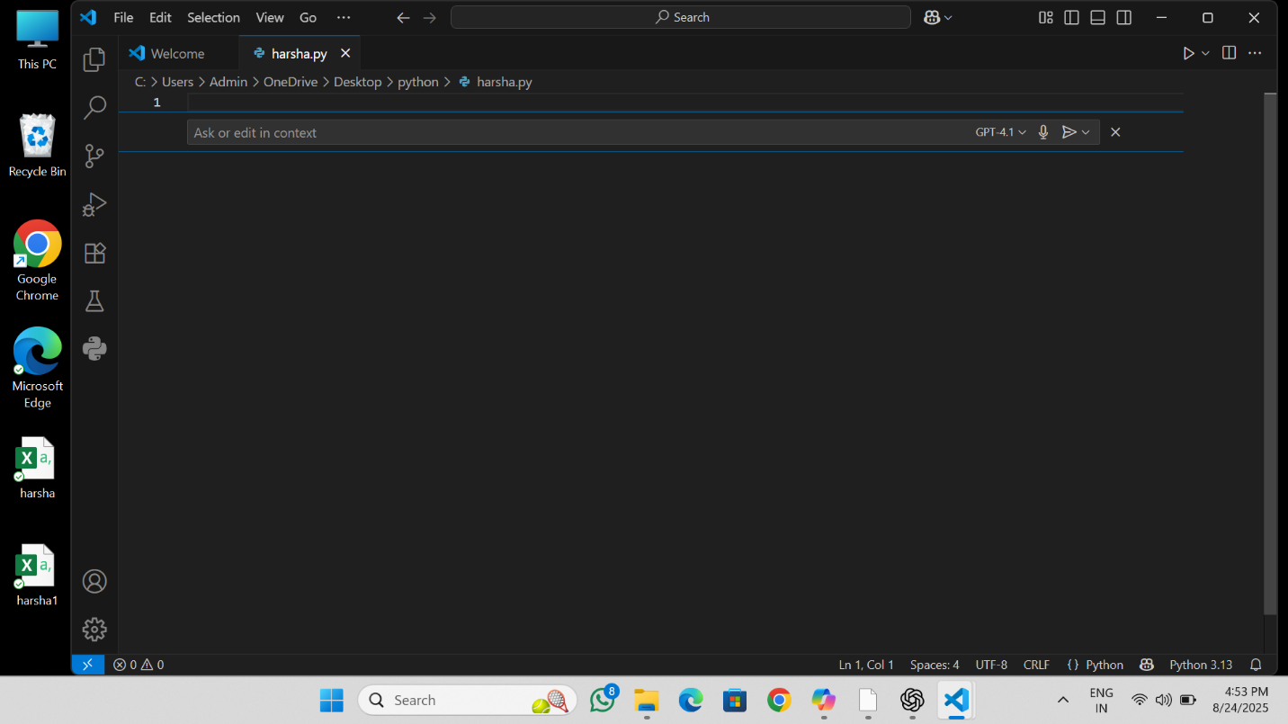

**2. Class Design Using AI Assistance**

* **Started defining a Product class** with attributes: name, price, and quantity.
* Began typing the __init__() method → **AI suggested the complete constructor**, which was accepted.
* Added a method **calculate_value()** → AI suggested returning price * quantity.
* Verified the function worked correctly by testing with sample inputs.

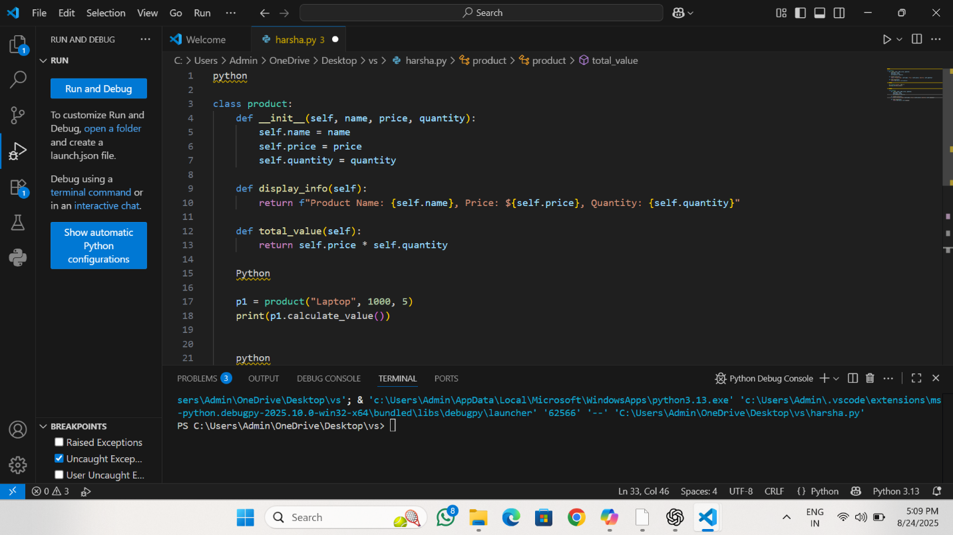

**3. Create Another Class**

* Defined a **Warehouse class** with an empty list to store Product objects.
* While typing the add_product() method, **AI suggested self.products.append(product)**, which was accepted.
* While typing the most_valuable_product() method, **AI suggested using max(self.products, key=lambda p: p.calculate_value())**, which correctly found the most valuable product.
* Wrote small test cases with multiple products to ensure the class worked as expected.

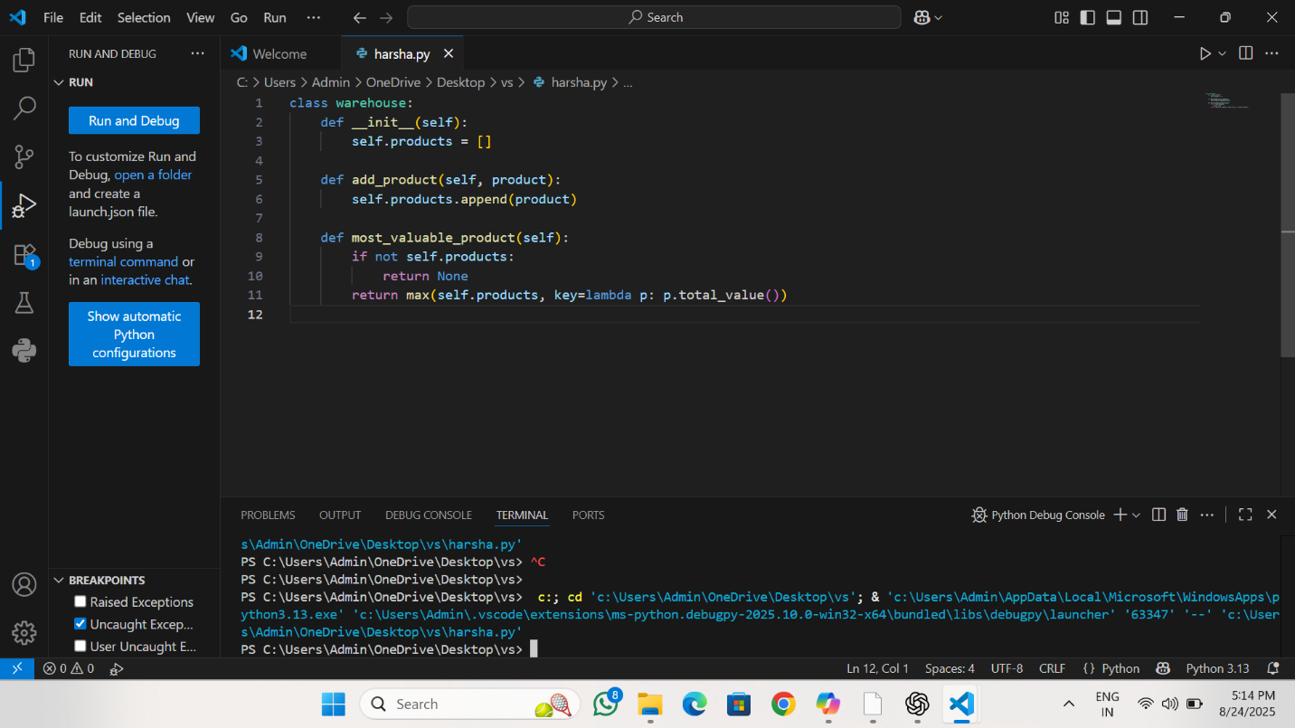

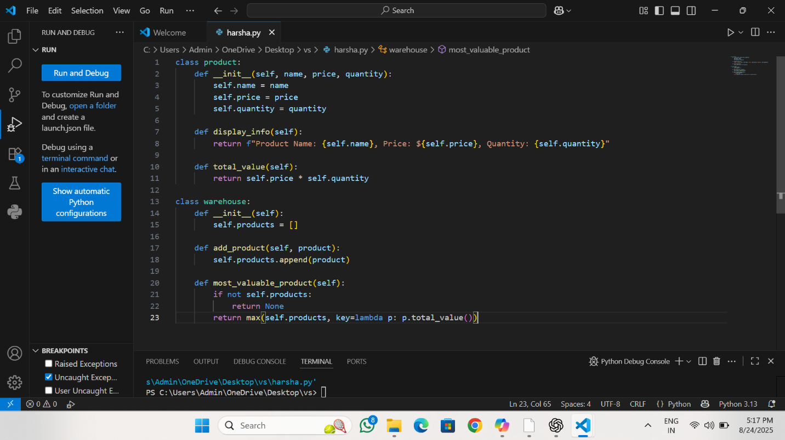

**4. Reflection**

* **AI Contribution:**
  + Suggested most of the boilerplate code (__init__, calculate_value(), add_product(), most_valuable_product()).
* **Manual Edits:**
  + Added test cases, comments, and structured the code to fit the assignment format.
* **Accuracy of Suggestions:**
  + AI suggestions were highly relevant and correct for all tasks.
  + Minimal debugging was required, showing AI was effective for this problem type.
* SUMMARY:

Iam writing summary on my own , while using AI in online applications and coding applications it was very easy and simply total writing the code instead clicking one tab button AI suggesting the suitable code

We have to gain the knowledge how to use AI means we can easily

Complete our works..